# Instructions for the self-guided tour.

***Navigating within the selected room***

1. Upon loading the tour will bring you to the first room. You will be able to use your mouse to navigate through the room.
2. You can zoom in and out, look up and down as well as left to right
3. By clicking on the blue circles on the floor will be able to move to another position in the room and look around.
4. By clicking on red information icons, information relative to the room or area will appear.

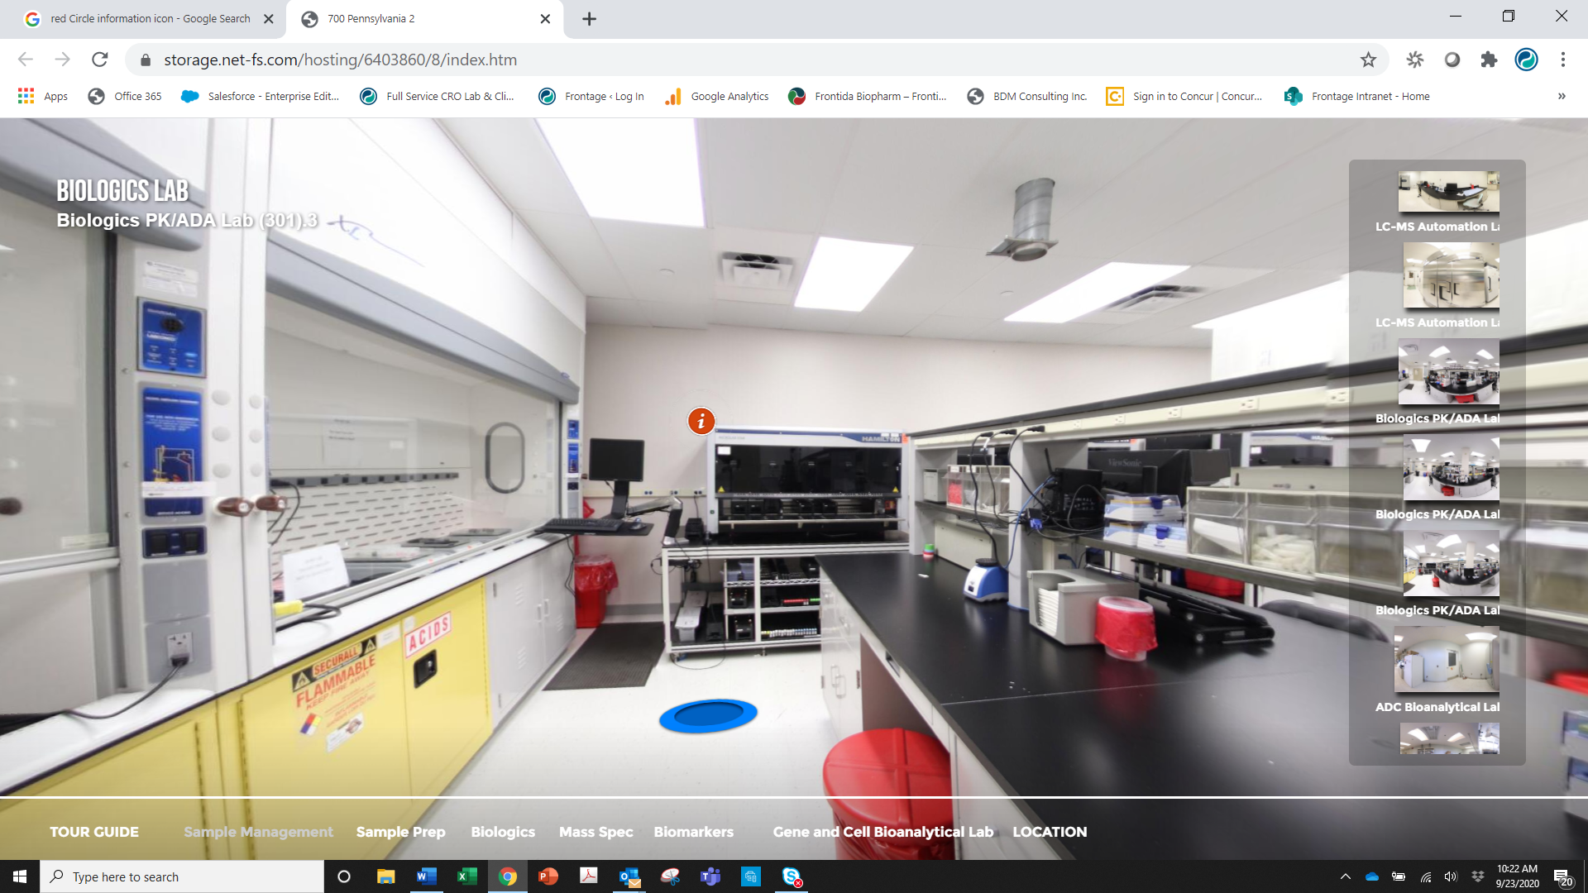

***Moving from room to room***

1. The upper left-hand corner will identify the room you are in.
2. On the bottom of the frame is a tour guide. You can select a functional area. A box will appear with the rooms related to that function.

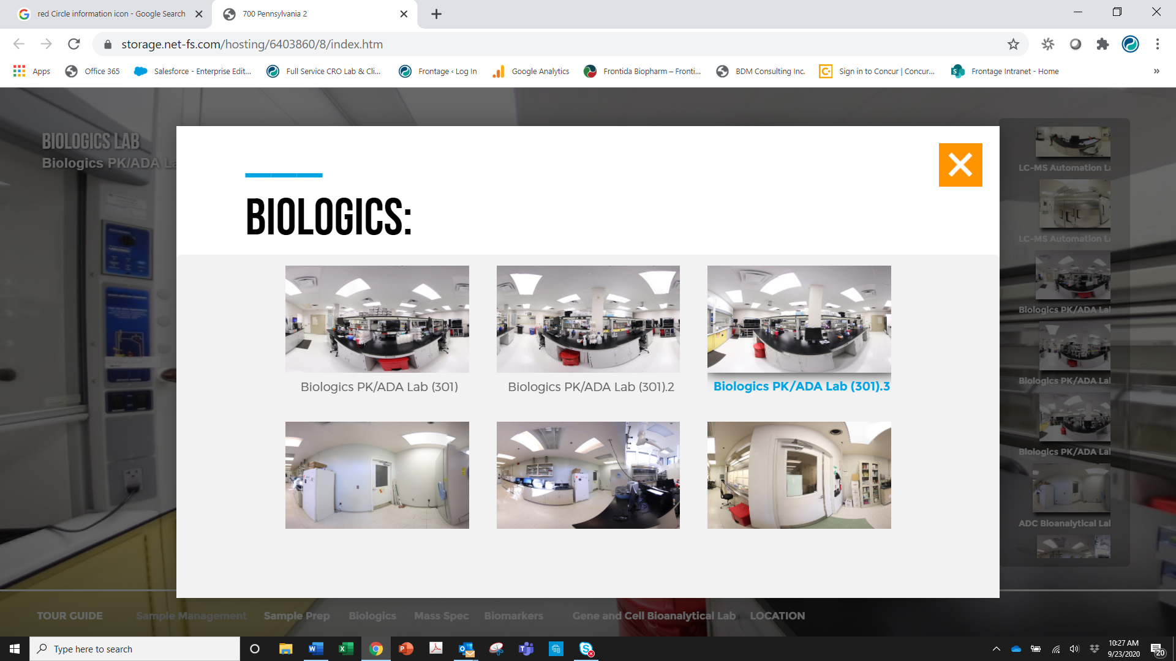

1. You can also scroll through the thumb nails on the right side to move through the tour room by room.